***Skill and chance***

***Revitalising Noughts and Crosses***

-Ben Miller

The game premise:

The Premise of the game created was a variation of Noughts and Crosses, a variation that would be played by 2-4 teams and would allow the players to indulge themselves in a game that would have more of a chance outcome then the original game, making each game have a variety of different outcomes where the same person would not win the game over and over again.

The material:

The material used within the creation of the game were as followed:

4 different shaped counters (15 of each) (shapes include: Square, Circle, Triangle, Cross)

A paper 6x6 grid

4 dice or less dice (1 for each team)

100 different question cards

Rules and mechanics/How the game is played:

The game is played following a set of simple steps, to begin with each team rolls a dice each to decide who goes first (highest goes first lowest goes last). Then to play, a dice is rolled, and that number determines what question card is pulled out. For example:

A roll of 1 = A Geography question

A roll of 2 = A Entertainment question

A roll of 3 = A History question

A roll of 4 = An Arts and literature question

A roll of 5 = A Science question

A roll of 6 = A General question

When you get the question, you need to answer it. If you get the answer correct then you can play a counter anywhere on the board, but if you do not, you fail the turn and do not get to place a counter. To win a team needs to have there of their counters in a row.

Play testing and creation:

To begin with the creation of the game, the team first had to design a board to be played on, and the team created this for playing:

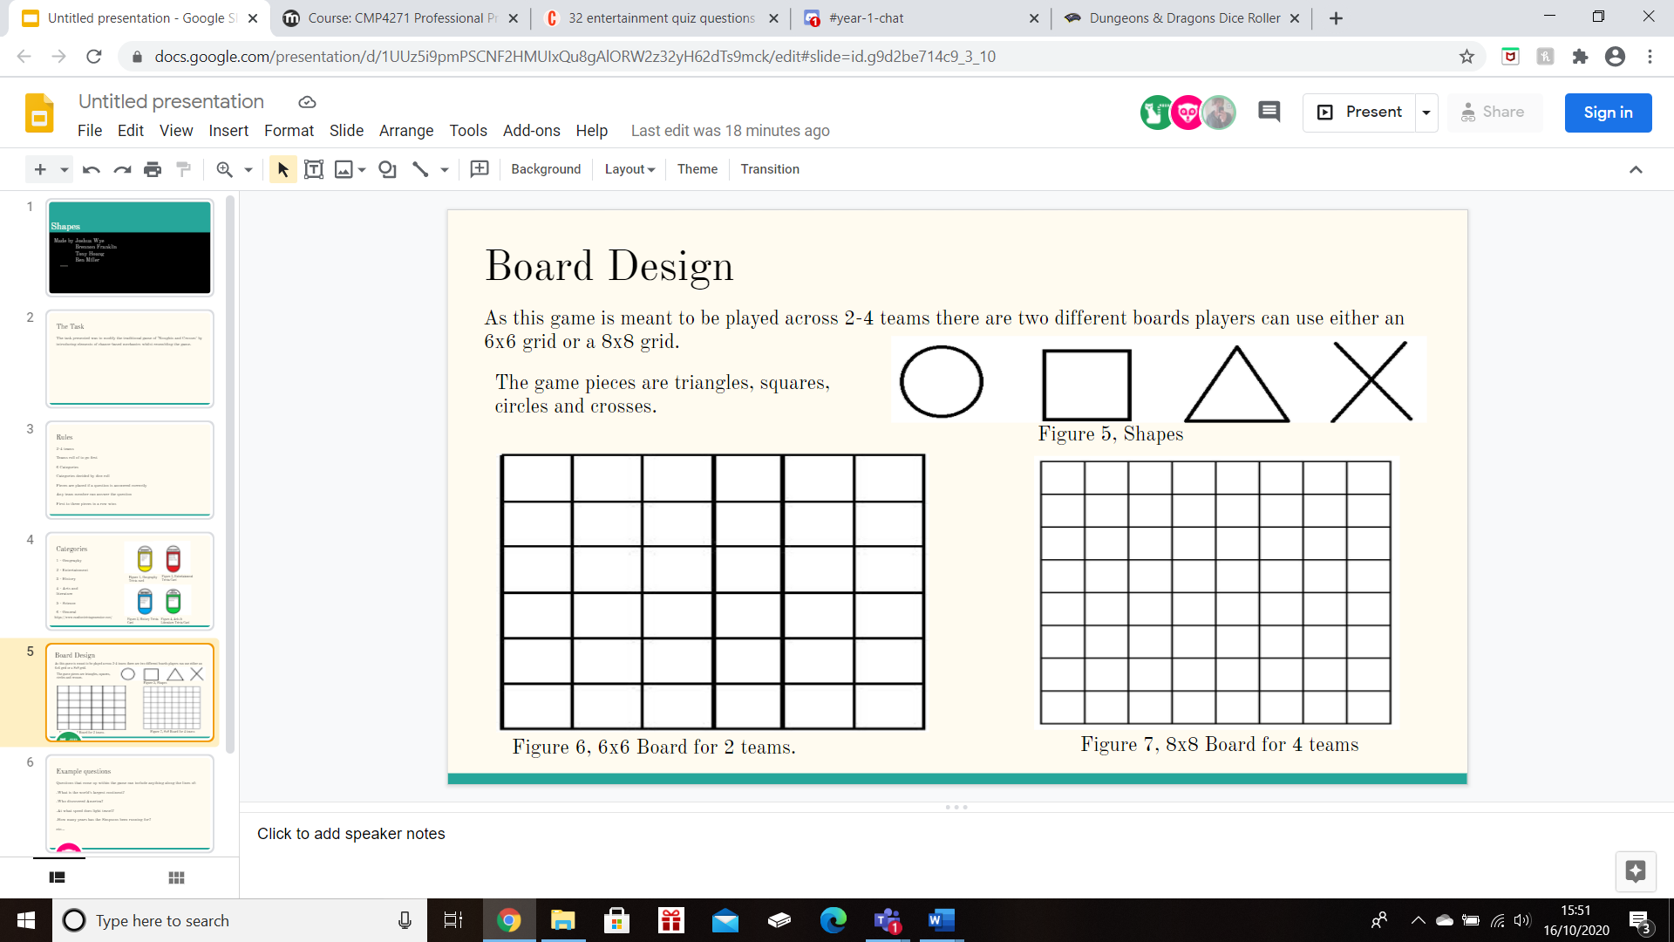

Figure 1 shows the board for the players to play on

During the playtesting of the game, the team found out that the game was completely playable and was actually a fairly fun game in the end.

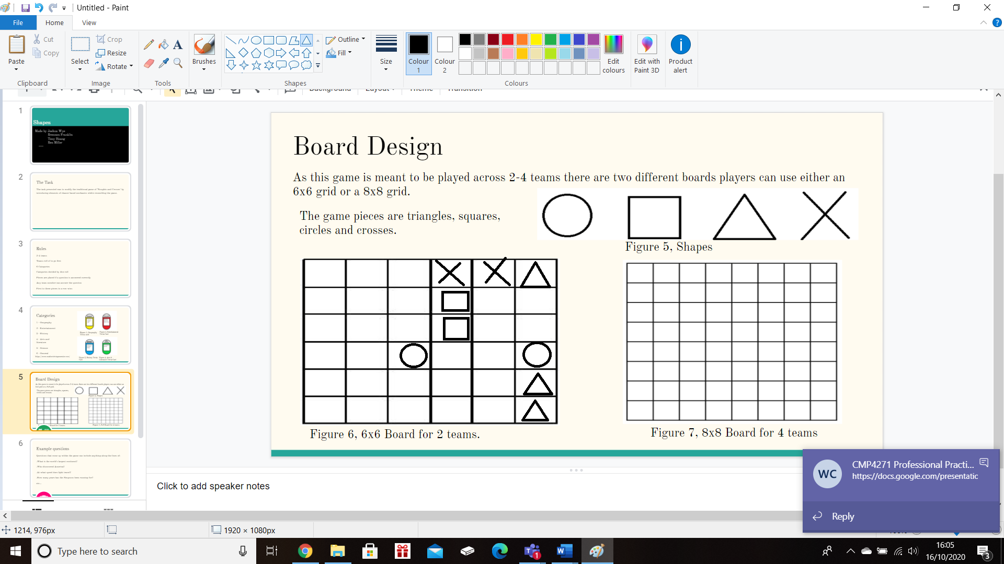

Figure 2 shows the game being played

Game testing:

During the testing of the game, we found that the game worked perfectly with no initial problems, this was due to the game being simple and there was no clear way to break the game. It also was an effective a game as each question is different in difficulty, meaning that the players would all run the risk of failing a turn, making it a fair game.

Problem solving in teams:

During the creation of the game, the team got together to help put together different ideas and concepts that would help shape the game fun and work. The teamwork allowed for 4 different individuals to create a premise, function, and rules for the game. One problem the team faced in the beginning was how the game didn’t originally have a unique take, and instead resembled a generic noughts and crosses game, but in the end, the team managed to make the idea for the questions, where each game would have a unique take and outcome.

What went well:

One thing that went well was that the team managed to get together to fully make a game that could be played without issue and without any problems.

Names:

Ben Miller

Joshua Wye

Brennon Franklin

Tony Hoang